Features of synoptic charts

Label and explain the following terms on the diagram of a synoptic chart:
isobar, high pressure system, low pressure system, weather front

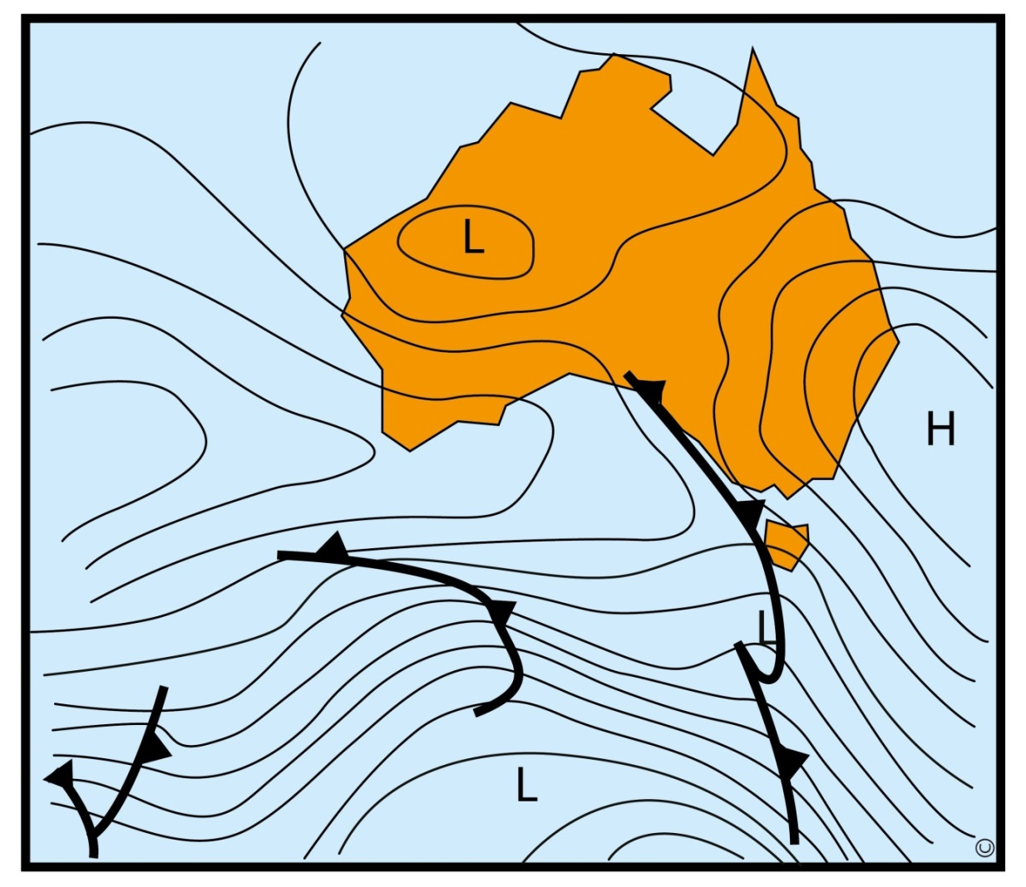
1.
3.
2.
4.

